Las Marionetas

Las cosas que necesitarán:
- Un rollo de papel del baño (el retrete) para el cuerpo.
- Bombillas para las piernas, brazos y cuello.
- Unos abalorios para las manos y los pies.
- Una bola de styrafoam para la cabeza o puede usar una bola pequeña tal como una bola de ping pong.
- Papel de construcción para el gorro de la marioneta.
- Cuatro clavijas o palos planos para hacerla mover.
- Hilo para conectar su Marioneta.
- Un “hole puncher” para hacer hoyos para los brazos y piernas.
- Material o fárico para decolarla.
- Una cinta de medir.

¿Cómo la haces?:
- First, decorate the toilet paper tube for the body and the Styrofoam ball for the head. You can glue on fabric, yarn and felt, or you can paint them.
- Now, use a hole puncher to punch two holes on the top of the tube, and two holes on the bottom. This is where the arms and legs will go.
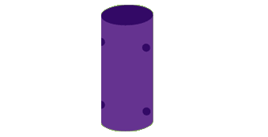
3. Next, cut a straw in half. Use a pencil to poke a small hole in your Styrofoam ball. Then, push one end of the straw into the ball.
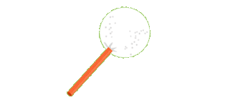
- Tape the other end of the straw to the inside of the toilet paper tube. You want to leave a little bit of the straw sticking out to make a neck.
- Cut two 24-inch long pieces of string. Thread one piece of string through the top two holes in the toilet paper tube. Then, thread the other string through the bottom holes.
- To make the arms and legs, cut four straws in half.
- Slide two straw pieces and a bead onto the end of each string. Tie a knot at the bottom of each string. Make sure the knots are big enough to keep the beads from slipping off.
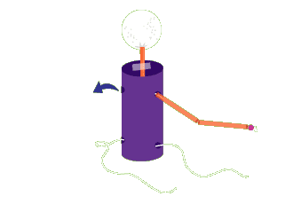
- Now, it's time to make a hat for your marionette. First, cut a small circle out of construction paper and then cut a V-shaped slice out of it.
- Then, cut a piece of string about 12 inches long. Tie a big knot at the end of the string and place the knotted end of the string in the center of the circle. The rest of the string goes through the V-shaped space in the circle.
- Fold the circle around the string to make a cone and tape it together. Make sure the knot is on the inside of the cone.
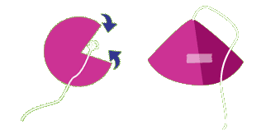
- Put some glue on the inside of the hat and stick it on top of the Styrofoam head. The body of your marionette is now complete.
- To make the controls, tape two dowels or sticks together. Now tape a third dowel to one end of the other two, so that it makes a T. Now do the same thing on the other end.
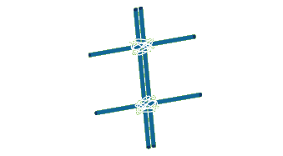
13. Tie the head string to the center of the back cross, where the dowels meet.
- Tie a 17 inch-long string to each of the hands and then attach them to each side of the back cross.
- Then, tie a 22 inch-long string to each of the knee joints on the legs. Attach these strings to each side of the front cross.
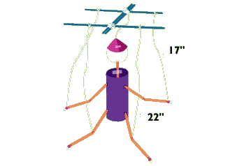
- Now, it's time to test it out. It may take a little bit of practice to get good at using your marionette. After a little practice, you can put on your own puppet show!

